# AGENDA

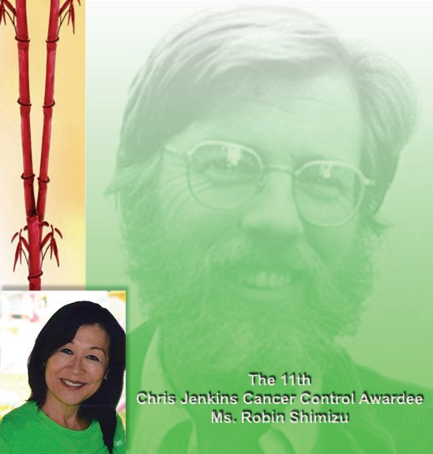

**6:00 PM Reception and Networking 6:30 Welcome**

***Tung Nguyen*, MD**

Principal Investigator, AANCART: The National Center

***Stephen McPhee,* MD**

Chair, Christopher Jenkins Cancer Control Award

**6:35 San Francisco AANCART**

***Tung Nguyen*, MD**

Co-Chair, SF-AANCART

**Announcement of Asian American Research Center on Health (ARCH)**

***Tung Nguyen,* MD** and ***Alka Kanaya*, MD**

ARCH Directors

**6:45 A Tribute to the Life and Work of Christopher Jenkins**

***Hy Lam***

VCHPP Media Specialist

**7:00 Introduction of 2012 Recipient of the Christopher Jenkins Cancer Control Award**

***Moon S. Chen, Jr.*, MPH, PhD**

Principal Investigator, AANCART: The National Center

**7:10 Christopher Jenkins Cancer Control Lecture**

***Robin Shimizu***

(Retired) Assistant Deputy Director for Chronic Disease Prevention and Health Promotion, State of California

**7:40 Questions and Answers 7:45 “Light”**

***Tung Nguyen,* MD**

**7:50 Award Presentation**

***Stephen McPhee,* MD** and ***Tuyet Tran,* MSW**

**7:55 Group Photograph**

**8:00 Adjourn**

**Chris Jenkins 2012 Cancer Control Awardee *Ms. Robin Shimizu***

**at “Quan Bac” Restaurant 4112 Geary Blvd., San Francisco**

**December 4th, 2012**

**Christopher N.H. Jenkins, MA, MPH**



Chris Jenkins, a native of Pennsylvania, graduated from Stanford University in 1966. He spent 2 years in Vietnam with International Voluntary Services, doing community development work. He then pursued a Masters Degree in Asian Studies from the University of California, Berkeley. In 1971, he married his wife, Tran Khanh-Tuyet, whom he had met in Vietnam. In 1982, he returned to the UC Berkeley and received his Masters Degree in Public Health in 1984. From 1984-2001, Mr. Jenkins worked at UC San Francisco. In 1986, he and his colleague, Dr. Stephen McPhee, started the Vietnamese Community Health Promotion Project (VCHPP). With funding from the Centers for Disease Control and Prevention, the National Cancer Institute, and the State of California, the Project has developed and evaluated interventions to promote smoking cessation and prevention, proper nutrition, screening for breast, cervical, and colon cancer, and hepatitis B screening and immunizations among Vietnamese.

**In 1995, Mr. Jenkins conducted the first national smoking prevalence survey in Vietnam. In 1998, he returned to Vietnam to advise the Ministry of Health in developing a national tobacco control policy. He and the VCHPP staff have published their research findings in the *Journal of the American Medical Association*, the *American Journal of Public Health*, *Preventive Medicine*, and *American Journal of Preventive Medicine,* among others.**

Prior to his untimely death in 2001, Mr. Jenkins served as an advisor to the Asian Pacific Partners for Empowerment and Leadership and the Intercultural Cancer Council, and on the Board of Directors of the Asian Pacific Islander American Health Forum.

# Ms. Robin Shimizu

Robin Shimizu has worked for the State of California, primarily in the Department of Health Services and the Department of Public Health, since 1972. In November 1989, Dr. Dileep Bal hired Robin to help begin the Tobacco Control Section (TCS), funded from the 25-cent tobacco tax that was passed by California voters in November 1988. Over the last 2 decades, the Tobacco Control Section gained worldwide recognition for its reducing tobacco use and exposure to secondhand smoke. As the Assistant Section Chief, Robin’s role was manage the TCS annual budget of about $60 million, and oversee the internal infrastructure of the program, including its personnel, policy development, accounting, contracts, legal, legislation, and overall office management. In addition, Robin and her colleagues oversaw development of a statewide anti-tobacco media campaign, featuring in-language television, radio, print and outdoor ads targeting a broad range of Asian populations. The State also funds a coordinated public relations campaign for the API population, a Smokers’ Helpline in four Asian languages, and numerous tobacco control intervention projects targeting the State’s Asian populations.

In July 2007, when the Department of Public Health was formed, Robin was promoted to the Assistant Division Chief of the Chronic Disease and Injury Control. In December 2007, she was promoted to the Assistant Deputy Director for Chronic Disease Prevention and Health Promotion. Finally, in June 2010, after over 37 years of state service, Robin retired.

Through the years, Robin has also served as a member of: the Board of Directors for the Sacramento American Heart Association; an advisory committee for the Robert Wood Johnson Smokeless States; and the Board of Directors for the Americans for Non-Smokers Rights Foundation; and as the National Community Director for AANCART.